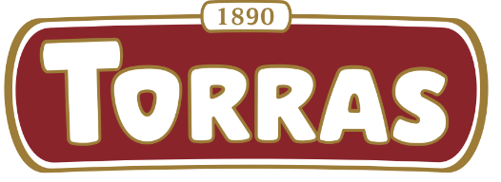
CHOCOLATES TORRAS
LAUNCHES TWO NEW ORGANIC CHOCOLATE BARS:
MATCHA & COCOA NIBS AND TURMERIC & BLACK PEPPER
Chocolates Torras expands its ORGANIC range with two new 70% dark chocolate varieties: ORGANIC Matcha & Cocoa Nibs and ORGANIC Turmeric & Black Pepper. Developed in collaboration with the renowned company Matcha & Co, both products are presented in a 100 g format and reinforce the company’s commitment to high-cocoa chocolate combined with distinctive organic superfoods.
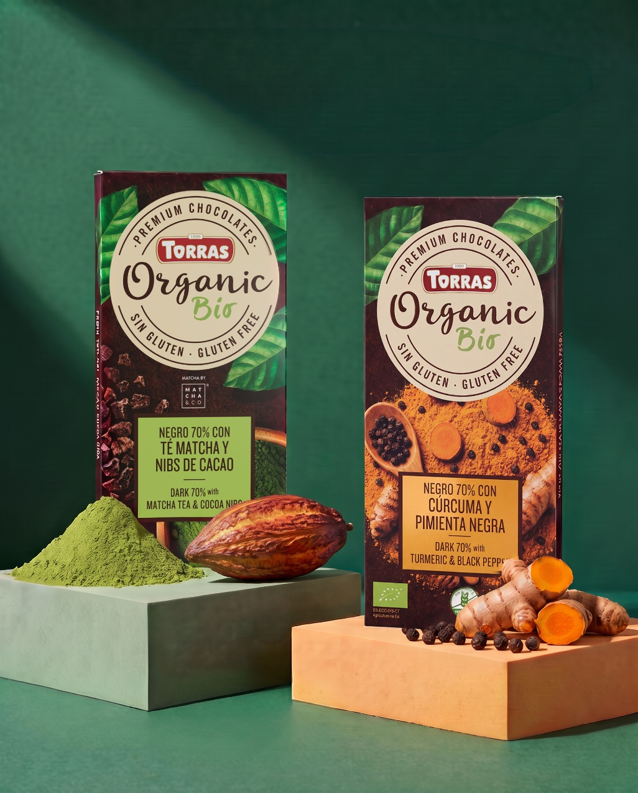

ORGANIC 70% MATCHA & COCOA NIBS LAUNCH

ORGANIC 70% Matcha & Cocoa Nibs is an innovative organic dark chocolate bar that combines the aromatic intensity of authentic Japanese matcha tea with the crunchy contrast of cocoa nibs.

Matcha naturally contains caffeine and L-theanine, while cocoa nibs provide theobromine and an unmistakable crunchy texture. Together, these ingredients create a unique sensory experience of intensity, vitality and indulgence, strengthening Torras’ position within the BIO and functional chocolate segment.

This product represents a unique proposition in the Spanish market, being the only organic 70% dark chocolate bar with matcha. Furthermore, it is made with organic matcha sourced from Japan, guaranteed by Matcha & Co, a leader in the premium matcha category, reinforcing the quality, authenticity and credibility of the product.
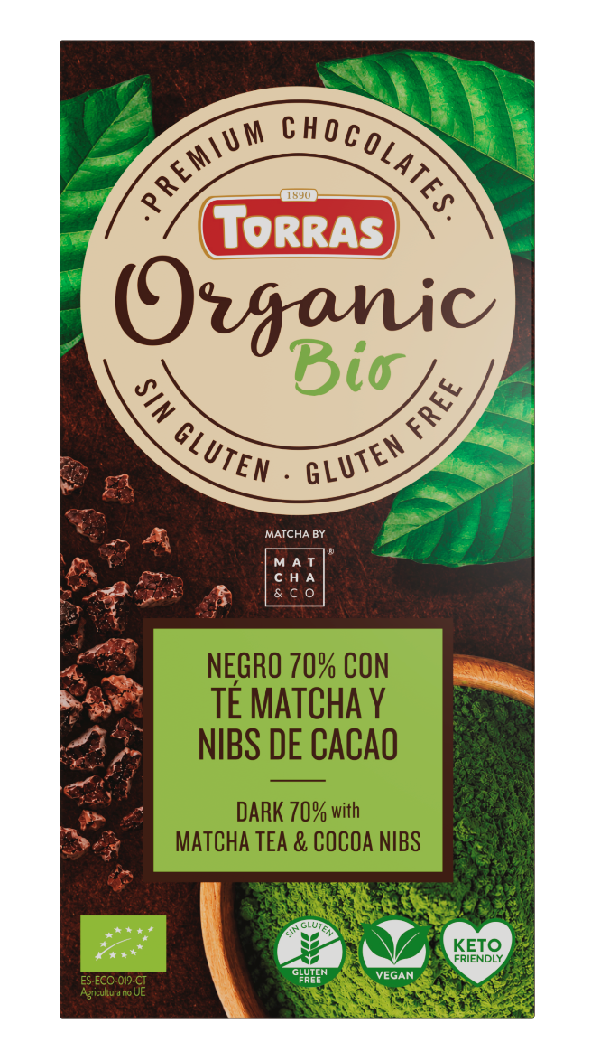
New ORGANIC 70% Matcha & Cocoa Nibs 70% - 100g

ORGANIC 70% TURMERIC & BLACK PEPPER LAUNCH

ORGANIC 70% Turmeric & Black Pepper is a surprising organic dark chocolate bar that combines two ingredients increasingly appreciated by consumers interested in wellness and natural nutrition: turmeric and black pepper.

This reference stands out for its warm, spicy and distinctive flavour profile, resulting from the combination of turmeric, widely recognised for its antioxidant properties, and black pepper, a complementary ingredient that enhances turmeric’s natural benefits.

The result is an original and sophisticated tasting experience aimed at consumers seeking innovative alternatives, functional ingredients and flavours with a strong personality.

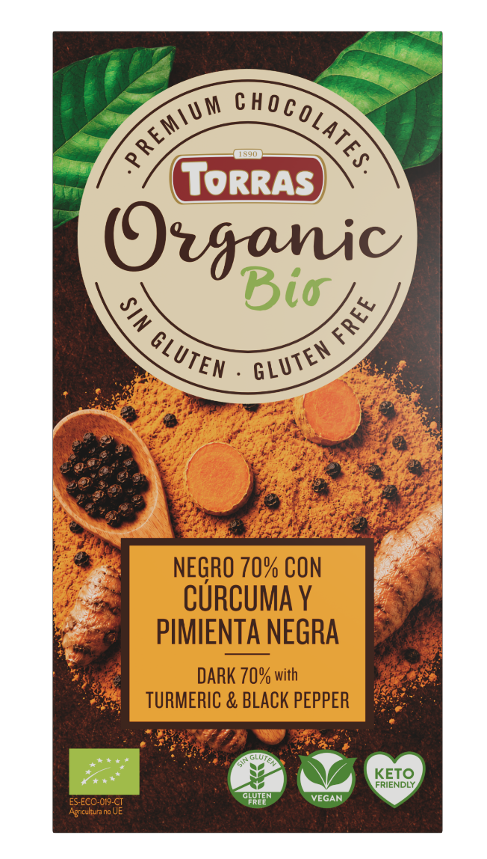
New ORGANIC 70%Turmeric & Black Pepper — 100g

With these two launches, Chocolates Torras continues to modernise and strengthen its ORGANIC BIO range, offering more distinctive and appealing options to consumers through 70% dark chocolate bars combined with organic superfoods aligned with current market trends and consumption preferences.

CHOCOLATES TORRAS MKT & SALES TEAM

